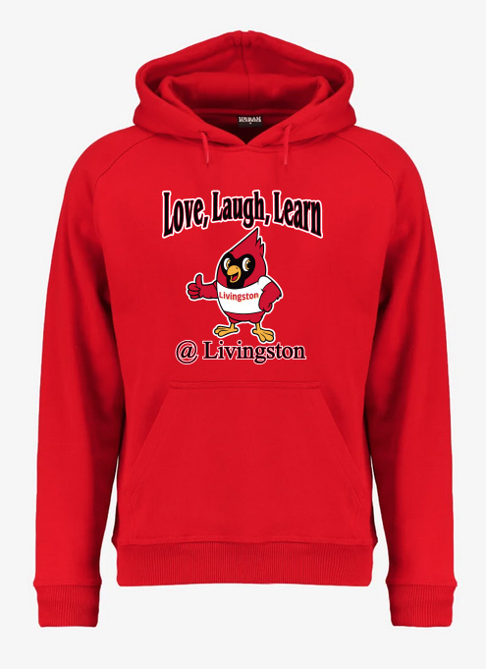
Order by November 15th
Livingston Hoodie Sale
Sizes s-6xl
s-xl -25.00
2xl -27.00
3xl- 28.00
4xl -29.00
5xl- 30.00
6xl- 32.00
These are adult sizes please judge accordingly for children.

